TASK 1:

#include<iostream>

using namespace std;

class Englishdistance

{

private:

float feet;

float inches;

public:

Englishdistance()

{

feet = 0;

inches = 0;

}

Englishdistance(float f,float i)

{

feet = f;

inches = i;

}

void getdata()

{

cout << "Enter the feet :";

cin >> feet;

cout << "Enter the inches :";

cin >> inches;

}

void operator +(const Englishdistance& obj)

{

this->feet += obj.feet;

this->inches += obj.inches;

}

void Show()

{

cout << "Feet= " << this->feet << endl;

cout << "Inches= " << this->inches << endl;

}

};

int main()

{

Englishdistance obj1;

obj1.getdata();

Englishdistance obj2(11.0, 6.25);

Englishdistance obj3;

obj1+obj2;

cout << "By adding obj1 and obj2 "<<endl;

obj1.Show();

obj3 = obj1;

obj3+obj1;

cout << "By adding obj1,obj2 and obj3"<<endl;

obj3.Show();

}

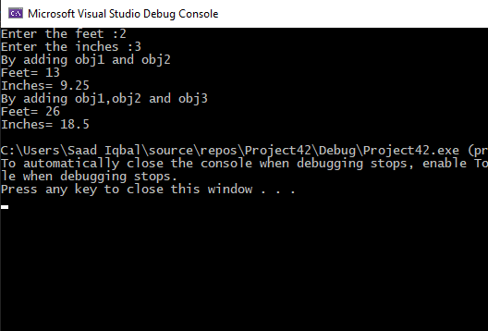

TASK 2

#include<iostream>

#include<string>

using namespace std;

void o();

class student

{

protected:

int admission_no;

string name;

int age;

public:

student()

{

admission_no = 0;

name = " ";

age = 0;

}

void setAdmission_no(int a)

{

admission_no = a;

}

int getAdmission_no()

{

return admission_no;

}

void setName(string n)

{

name = n;

}

string getName()

{

return name;

}

void setAge(int ag)

{

age = ag;

}

int getAge()

{

return age;

}

void input()

{

cout << "Enter the admission number of the student :";

cin >> admission_no;

cout << "Enter the name of the student :";

cin >> name;

cout << "Enter the age of the student :";

cin >> age;

}

void display()

{

cout << "The admission number of the student is " << admission_no<<endl;

cout << "The name of the student is " << name<<endl;

cout << "The name of the student is " << age<<endl;

}

};

class graduatestudent:public student

{

protected:

string degree;

public:

graduatestudent():student()

{

degree = "sd";

}

void setDegree(string d)

{

degree = d;

}

string getDegree()

{

return degree;

}

void input()

{

student::input();

cout << "Enter graduate program :";

cin.ignore();

getline(cin,degree);

}

void display()

{

cout << "** Graduate program **"<<endl;

student::display();

cout << "The degree program is :"<<degree<<endl;

}

};

class undergraduatestudent :public student

{

protected:

string degree;

public:

undergraduatestudent() :student()

{

degree = " ";

}

void setDegree(string d)

{

degree = d;

}

string getDegree()

{

return degree;

}

void input()

{

student::input();

cout << "Enter degree program :";

cin.ignore();

getline(cin, degree);

}

void display()

{

cout << "** UnderGraduate Student **" << endl;

student::display();

cout << "The degree program is :" << degree << endl;

}

};

int main()

{

graduatestudent o;

undergraduatestudent ug;

o.input();

ug.input();

o.display();

ug.display();

}

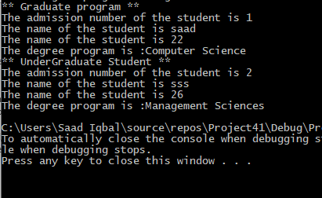

TASK 3:

#include<iostream>

using namespace std;

class student

{

private:

int rollnumber;

public:

student()

{

rollnumber = 0;

}

void getdata()

{

cout << "Enter the roll number of student :";

cin >> rollnumber;

}

void showdata()

{

cout << "The roll number of the student is :"<<rollnumber;

}

};

class test:public student

{

protected:

int subject1;

int subject2;

public:

test():student()

{

subject1 = 0;

subject2 = 0;

}

void getdata()

{

student::getdata();

cout << "Enter the marks in subject 1 out of 100 :";

cin >> subject1;

cout << "Enter the marks in subject 2 out of 100 :";

cin >> subject2;

}

void showdata()

{

cout << "The marks in subject 1 is :"<<subject1<<endl;

cout << "The marks in subject 2 is :" << subject2 << endl;

}

};

class sport :public student

{

protected:

int score;

public:

sport()

{

score = 0;

}

void getdata()

{

cout << "Enter the score of the student out of 100 :";

cin >> score;

}

void showdata()

{

cout << "The score of the student is :"<<score<<endl;

}

};

class result :public test,public sport

{

public:

result():test(),sport()

{

}

void getdata()

{

test::getdata();

sport::getdata();

}

void showdata()

{

test::showdata();

sport::showdata();

}

void getresult()

{

int result = subject1 + subject2+score;

int average = result / 3;

cout << "The sum of the subjects and sport score is :" << result<<endl;

cout << "The average is" << average << endl;

}

};

int main()

{

result obj;

obj.getdata();

obj.showdata();

obj.getresult();

}

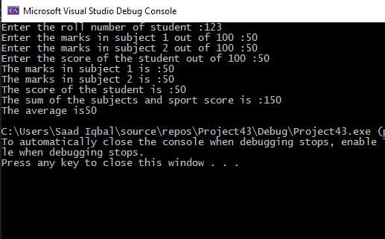

Task 4:

#include<iostream>

#include<string>

using namespace std;

class student

{

private:

string universityname;

string degree;

public:

student()

{

universityname = " ";

degree = " ";

}

void getdata()

{

cout << "Enter the universty name of student :";

cin >> universityname;

cout << "Enter the degree program of the student :";

cin >> degree;

}

void showdata()

{

cout << "The university name of the student is :"<< universityname<<endl;

cout << "The degree name of the student is :" << degree<<endl;

}

};

class Employee

{

private:

int id;

string name;

public:

Employee() {

name = " ";

id = 0;

}

void getdata()

{

cout << "Enter the name of the employee :";

cin >> name;

cout << "Enter the id of the employee:";

cin >> id;

}

void showdata()

{

cout << "The name of the employee is :"<<name<<endl;

cout << "The id of the employee is :" << id << endl;

}

};

class scientist :public student

{

private:

int numberofpublication;

public:

scientist():student()

{

numberofpublication = 0;

}

void getdata()

{

student::getdata();

cout << "Enter the number of publications of the students :";

cin >> numberofpublication;

}

void showdata()

{

cout << "Detail of the Scientist"<<endl;

student::showdata();

cout << "The number of publications of student is "<< numberofpublication<<endl;

}

};

class Manager :public Employee

{

private:

int dues;

string title;

public:

Manager():Employee()

{

dues = 0;

title = " ";

}

void getdata()

{

Employee::getdata();

cout << "Enter the dues of the manager :";

cin >> dues;

cout << "Enter the title of the manager :";

cin >> title;

}

void showdata()

{

cout << "Detail of the Manager" << endl;

Employee::showdata();

cout << "The dues of the manager :" << dues << endl;

cout << "The title of the manager :" << title << endl;

}

};

int main()

{

Manager m;

scientist s;

m.getdata();

s.getdata();

m.showdata();

s.showdata();

}

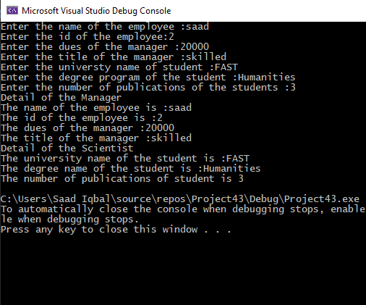

Task 5:

#include<iostream>

#include<string>

using namespace std;

class Employee

{

protected:

int id;

string name;

public:

Employee()

{

id = 0;

name = " ";

}

void getdata()

{

cout << "Enter the id of the employee :";

cin >> id;

cout << "Enter the name of the employee :";

cin.ignore();

getline(cin,name);

}

void showdata()

{

cout << "The id of the employee is :"<<id<<endl;

cout << "The name of the employee is :" << name << endl;

}

virtual void calculatepay() = 0

{

cout << "Error!"<<endl;

}

};

class Manager:public Employee

{

protected:

int salary;

public:

Manager()

{

salary = 0;

}

void getdata()

{

Employee::getdata();

cout << "Enter the salary of the employee :";

cin >> salary;

}

void calculatepay()

{

Employee::showdata();

cout << "The salary of the Employee is " << salary << endl;

}

void showdata()

{

Employee::showdata();

calculatepay();

}

};

class Hourly :public Employee

{

protected:

int salaryperhour;

int hours;

public:

Hourly()

{

salaryperhour = 0;

hours = 0;

}

void getdata()

{

Employee::getdata();

cout << "Enter the salary of the employee :";

cin >> salaryperhour;

cout << "Enter the hours worked by the employee :";

cin >> hours;

}

void calculatepay()

{

Employee::showdata();

int result;

result = salaryperhour * hours;

cout << "The salary of the Employee is " << result << endl;

}

void showdata()

{

Employee::showdata();

calculatepay();

}

};

int main()

{

int option;

cout << "Enter 1 to know the details of manager :"<<endl;

cout << "Enter 2 to know the details of hourly Employee :" << endl;

cin >> option;

if (option == 1)

{

Manager m;

m.getdata();

m.calculatepay();

}

if (option == 2)

{

Hourly m;

m.getdata();

m.calculatepay();

}

}

